**HORMISDALLEN SCHOOL - KYEBANDO**

**PRE- PLE SET 8 EXAMINATIONS, 2023**

**PRIMARY SEVEN SOCIAL STUDIES**

**Duration: 2 Hours 15 Minutes**

**NAME: ______________________________________________ STREAM: _________**

INDEX NO.

EMIS NO.

**SECTION A**

1. Name one river in Africa that flows into the Mediterranean Sea.

………………………………………………………………………………………………….

1. Give any one way modern communication promotes trade.

……………………………………………………………………………….……………….

1. Why is the government of Uganda promoting skilling programs for the youth?

……………………………………………………………………………….……………….

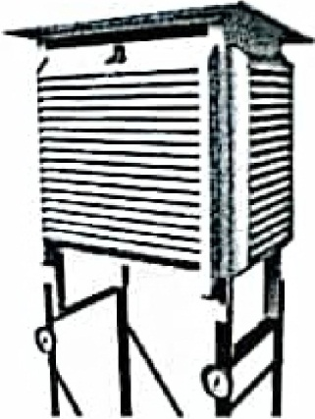Study the diagram below and answer the questions that follow. (4-5)

1. Name the structure above as used at weather stations.

……………………………………………………………………………….……………….

1. What is the function of the above structure at a weather station?

……………………………………………………………………………….……………….

1. How did industrial revolution of Europe lead to the coming of the European colonialists to Africa?

……………………………………………………………………………….……………….

1. State any one economic importance of Fort Jesus to Kenya.

……………………………………………………………………………….……………….

1. What is meant by the term Apartheid policy?

……………………………………………………………………………….……………….

…………………………………………………………………………………………………

1. Give one way the government gets information from people.

……………………………………………………………………………….……………….

1. State one reason why a country with a fast growing population should modernize her agricultural sector.

……………………………………………………………………………….……………….

1. Why did Ugandans demand for representation on the LEGCO during colonial rule?

……………………………………………………………………………….……………….

1. Mention one disadvantage of civil wars in the development of a country.

……………………………………………………………………………….……………….

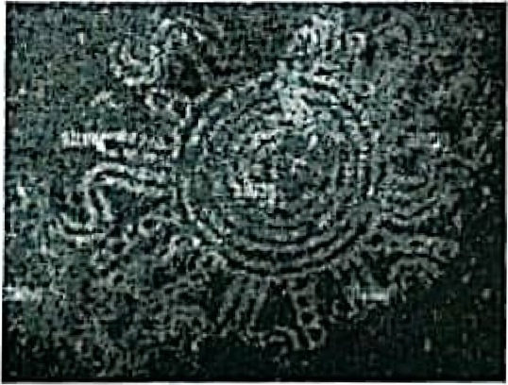**The diagram below shows a rock with ancient paintings. Use it to answer the questions that follow. (13-14)**

1. Name one archaeological site in Uganda where rock paintings are found.

……………………………………………………………………………….……………….

1. State any one economic importance of rock paintings.

……………………………………………………………………………….……………….

1. Give any one factor that attracts many people to migrate to towns.

……………………………………………………………………………….……………….

1. How do farmers benefit from agro based industries in their area?

……………………………………………………………………………….……………….

1. In which way did the creation of Eritrea affect the location of Ethiopia?

……………………………………………………………………………….……………….

1. How is a police station important in the community?

………………………………………………………………………………………………..

1. Why did Germany lose Rwanda and Burundi after World war I?

…………………………………………………………………………………………….….

1. A civil servant earns sh.500,000 as his monthly salary. His total expenditure is sh.300,000 a month. In the space provided below, draw a diagram to show the budget of the above civil servant.
2. What type of budget is drawn above?

…………………………………………………………………………………………….….

1. State one way of conserving culture in our community.

……………………………………………………………………………………….…….....

1. How did slave trade affect labour in East Africa?

……………………………………………………………………………………….……….

1. Name any block mountain in Uganda.

………………………………………………………………………………………….…….

1. State any one way in which Imperial British East Africa Company (IBEACO) contributed to the spread of Christianity in East Africa.

………………………………………………………………………………………………..

1. Why do some areas in East Africa experience hot temperatures?

………………………………………………………………………………….…………….

1. What is meant by the term monetary trade?

…………………………………………………………………………………….……………………………………………………………………………………………………………….

1. Give any one cause of domestic violence in families today.

……………………………………………………………………………….……………….

1. What does the symbol below represent on a map?



……………………………………………………

1. How is a dry season useful to crop farmers?

…………………………………………………………………………………….………….

1. Which European explorer drowned at Bussa falls in West Africa?

…………………………………………………………………………………………….….

1. Why is New York City useful to the United Nations? (UN)?

………………………………………………………………………………………….…….

1. State one way in which a school can promote children’s talents.

…………………………………………………………………………………………….….

1. What body carries out populations Census in Uganda?

…………………………………………………………………………………………….….

1. Name the political party system used in Uganda.

………………………………………………………………………………………………..

**For questions 36-40, answer Either Christianity OR Islamic questions but not both.**

1. **Either:** Name the prophet known for his suffering and endurance in the Bible.

………………………………………………………………………………………….…….

**OR:** Name the prophet known for his suffering and endurance in the Quran.

………………………………………………………………………………………….…….

1. **Either:** How is Bethlehem an important place in the history of Christianity?

………………………………………………………………………………………………..

**OR:** How is Mecca an important place in the history of Islam?

………………………………………….…………………………………………………….

1. **Either:** Who was the brother of Jacob the father of Joseph?

…………………………………………….………………………………………………….

**OR:** Who was the brother of Yakoub the father of Yussuf?

………………………………………….…………………………………………………….

1. **Either:** In which way did God communicate to Mary about the birth of Jesus Christ?

……………………………………….……………………………………………………….

**OR:** In which way did Allah communicate to Mariam about the birth of Prophet Isa?

…………………………………….………………………………………………………….

1. **Either:** How did God renew his relationship with man after the sin of Adam and Eve?

…………………………………….………………………………………………………….

**OR:** Give any one way Muslims renew their relationship with Allah.

……………………………………….……………………………………………………….

**SECTION B**

1. a) State any one role of the Electoral Commission in Uganda.

……………………………………….……………………………………………………….

b) Mention any two bad practices done by people during elections.

i)…………………… ……………….………………………………………………………

ii)…………………… ……………….………………………………………………………

c) Give any one document used to identify a legible voter during elections.

……………………………………….……………………………………………………….

1. a) To which organ of government do ministers belong?

…..…………………… ……………….………………………………………………………

b) Write any two roles of the legislature organ of the government.

i)…………………… ……………….………………………………………………………

ii)…………………… ……………….………………………………………………………

c) What title is given to the head of the judiciary organ of government?

……………….……………….……………….……………….……………….………………

1. a) Give any one importance of Oases to people in the Sahara desert.

……………………………………………….……………………………………………….

b) Mention any one factor that leads to desert conditions in Sahara region.

………………………………………………………………………………………………….

c) Name any two countries in Africa that experience desert climate.

i)…………………… ……………….………………………………………………………

ii)…………………… ……………….………………………………………………………

1. a) Name any two member countries of Economic Community of West Africa States. (ECOWAS)

i)…………………… ……………….………………………………………………………

ii)…………………… ……………….………………………………………………………

b) State any two benefits of ECOWAS to countries named in (a) above.

i) ..……………………………… ……………….…………………………………………....

ii) ……………………………………………….…………………………………………….

1. Study the map of East Africa below and answer questions that follow.

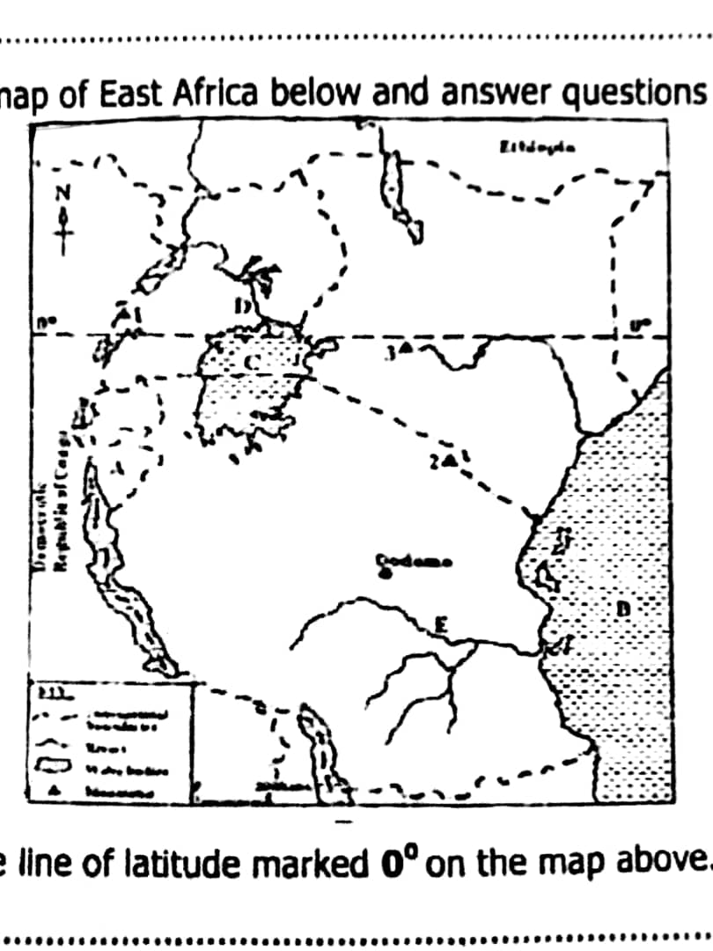

1. Name the line of latitude marked O**0** on the map above.

……………………………………………….……………………………………………….

b) How was the river marked D important to fighters of the Maji Maji rebellion in Tanzania?

…………………………………………….………………………………………………….

c) Give any one reason why the shores of lake C are suitable for farming.

…………………………… ……………….…………………………………………………

d) Name the country marked A on the map above.

………………………… ……………….…………………………………………………

1. a) State any two importance of cattle to nomadic pastoralists.

i)…………………… ……………….………………………………………………………

ii)…………………… ……………….………………………………………………………

b) State two problems faced by pastoral tribes in East Africa.

i)…………………………………………………… ……………….………………………

ii)…………………………………………………… ……………….……………………..

1. 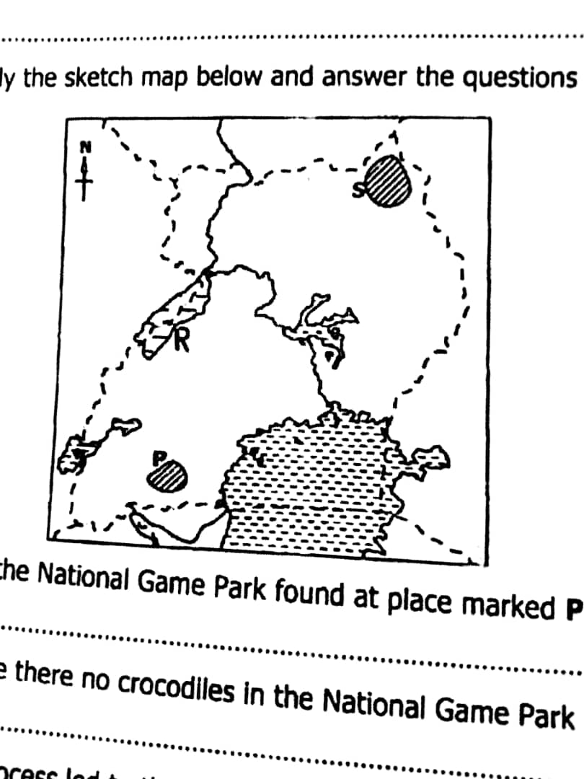**Study the sketch map below and answer the questions that follow.**
2. Name the national Game Park found at place marked P.

………………………………………………………………………………………………

1. Why are there no crocodiles in the National Game Park marked S?

………………………………………………………………………………………………

1. What process led to the formation of lake marked R?

………………………………………………………………………………………………

1. **Use letter Q to indicate Lake Kyoga on the map.**
2. a) What represents each of the following on Uganda Coat of Arms?
3. Uganda’s tropical climate

………………………………………………………………………….…………………….

1. Traditional culture.

………………………………………………………………………….…………………….

1. Uganda’s wildlife

………………………………………………………………………….…………………….

b) Mention any one way of showing respect for the Uganda Anthem.

…………………………………………………………………….………………………….

1. a) State any one way of promoting children’s rights at home.

…………………………………………………………………………………………………

b) Give any two reasons why children should enjoy their rights.

i) ..………………………………………… ……………….………………………………....

ii) ………………………………………………………….………………………………….

c) Mention any one cause of child abuse in your community.

……………………………………………………………………………….

1. a) What is the source of solar energy?

…….…………………………………………… ……………….……………………………..

b) Give two importance of solar energy at home.

i) ..………………………………………… ……………….………………………………....

ii) ………………………………………………………….………………………………….

c) Mention any one advantage of solar energy over hydroelectricity.

……………………………………………………………….…………………………….

**For questions 51-55, answer EITHER Christianity OR Islamic questions but not both.**

1. **Either:** a) Apart from the Bible, mention any two other ways God communicates to people.

i) ………………………………………………………………….………………………….....

ii)………………………………………………………………….………………………….....

b) Name any two law books in the Bible that were written by Moses.

i) …………………………………………………………….…………………………….....

ii) …………………………………………………………….…………………………….....

**OR:** a) Apart from the Quran, mention any two other ways Allah communicateso people.

i) ………………………………………………………………….………………………….....

ii)………………………………………………………………….………………………….....

b) Name any two other religious books in Islam apart from the Quran.

i) …………………………………………………………….…………………………….....

ii) …………………………………………………………….…………………………….....

1. **Either:** a) What do the following represent in Holy Communion?

i) Bread……………………………………………………….………………………….....

ii) Wine ………………………………………………………….………………………….....

b) Give any one title of a religious leader who conducts Holy Communion.

………………………………………………………………….………………………….....

c) Why do Christians receive the sacrament of Holy Communion?

……………………………………………………………….………………………….....

**OR:** a) What does circumcision represent in Islam?

………………………………………………………………….………………………….....

b) Name the pillar where food and other material things are shared among Muslims.

…………………………………………………………………….………………………...

c) Give two reasons why Moslems should fulfill the pillars of Islam.

i) ……………………………………………………………….………………………….....

ii) …………………………………….…………………………………………………….....

1. **Either:** a) Who led the Jews to arrest Jesus Christ?

**…**..……..……………………………………….……………………………………………

b) Why was Jesus Christ arrested?

………..……………………………………………………….……………………………

c) Why was Jesus taken to Pontius Pirate?

…………………..………………………………………………….………………………

d) Name the town where the body of Jesus was buried.

………………………………………………………………………….…………………….

**OR:** a) In which day do Muslims celebrate the death of Prophet Muhammad?

**…**..……..……………………………………………………………….……………………

b) Mention any two reasons why Prophet Muhammad migrated to Medina.

1. ………..…………………………………………………………….………………………
2. …………………..………………………………………………….………………………

c) Where was the body of Prophet Muhammad buried?

………………………………………………………………………….…………………….

1. **Either:** a) Why do Christian celebrate Palm Sunday?

………..…………………………………………………………….………………………

b) How did people welcome Jesus Christ to Jerusalem on Palm Sunday?

i) ………..……………………………………………………………….……………………..

ii) ……….………………………………………………………………….…………………..

c) Name the animal Jesus used for transport to Jerusalem on Palm Sunday.

…………………………………………………………………………….………………….

**OR:** a) Give the title these groups of people get after making a pilgrimage to Mecca.

1. Male Muslims

………..………………………………………………………………….…………………

1. Female Muslims

…………………..……………………………………………………….…………………

1. State any one reason why Muslims visit the tombs of Medina.

………………………………………………………………………………………………

1. Mention any one Holy Mosque that Muslims visit on a Pilgrimage.

………………………………………………………………………………………………

1. **Either:** a) Give any two ways Christians benefit from fasting.

i) ………..……………………………………………………………….……………………..

ii) ……….………………………………………………………………….…………………..

b) State any two things that Christians should not do during the fasting.

i) ………..……………………………………………………………….……………………..

ii) ……….………………………………………………………………….…………………..

**OR:** a) Give any two ways Muslims benefit from fasting.

i) ………..……………………………………………………………….……………………..

ii) ……….………………………………………………………………….…………………..

b) State any two things that Muslims should not do during the fasting.

i) ………..……………………………………………………………….……………………..

ii) ……….………………………………………………………………….…………………..

**\*\*\*END\*\*\***